Part 1: Physical background

Explosion hazard due to electrostatic charges
In many industries, the use of flammable liquids produces gases which, in combination with atmospheric oxygen, create an explosive atmosphere. An explosion of this ignitable mixture can only occur if an ignition source is also present. An ignition source that arises through contact and separation of the flammable liquid, i.e. through pumping over, stirring, mixing, sampling as well as cleaning work, are the feared electrostatic charges. If a gas discharge occurs due to high electrostatic charge with sufficiently high energy, an explosion will occur which may result in significant personal injury and property damage. 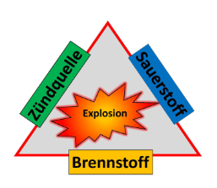
Graphic Eltex:
Hazard triangle
(own illustration)

An explosion occurs when all three factors fuel, oxygen and ignition source coincide in time and space!

The problem of electrostatic charges of solvent-containing liquids, containers, buckets or drums is that they can neither be seen, smelled nor felt. Often the personnel is not sufficiently trained or underestimates the high danger of a gas discharge and its fatal consequences. The mandatory grounding of all conductive objects cannot be checked with simple ground contactors!

When filling or unloading trucks, larger containers or even BigBags, the use of active ground monitoring systems is standard in most industries. However, smaller containers are too often underestimated and insufficient or no grounding measures are taken. A "dangerous quantity" is considered in enclosed spaces, however, already from 10l. (Source: www.exinfo.de)!
In order to reduce the invisible ignition source of electrostatically charged substances and containers to a non-hazardous level, the generation must be understood and appropriate countermeasures must be taken so that these substances and containers do not become dangerously charged and a gas discharge can occur.

Objects or equipment made of conductive materials must be grounded in hazardous areas according to TRGS 727! Eltex Elektrostatik GmbH offers professional solutions with modern grounding systems for this purpose, with which the correct ground connection is actively, defined and continuously monitored!

Simple passive ground contactors, such as battery clamps or welding tongs, often give a false sense of safety. The user has no way of determining whether a continuous earth connection with the equipotential bonding has actually been established after the ground clamp has been applied and whether this connection will remain in place for the duration of a transfer process. With an active grounding system, this can be indicated visually and/or by interlocking.

Part 2: Equipment in gravure printing

In gravure printing plants, in the area of flexible packaging, cigarette printing or illustration printing, solvent-based inks are almost exclusively used for printing.

On its way from the truck to the press, the solvent-based ink passes through several areas of the company. Wherever the solvent-based ink is pumped, mixed or metered, dangerous electrostatic charges can occur which, in the event of a gas discharge, can lead to high property damage and/or personal injury. To prevent this, the active ground monitoring systems must be used at the neuralgic points instead of the simple passive ground clamps. The risk of a missing or insufficient ground connection is thus significantly reduced.

The handling of solvent-based ink or solvents is very similar in different plants. In the areas described below, it is necessary to use an active ground monitoring system.

Solvent supply
The solvent is delivered to the printing plant by tanker trucks and filled into tanks at the company outside the building. Since larger quantities are delivered and the tanker is always unloaded at the same point, the TERRACONTROL TUE30 ground monitoring system equipped with an interlock or the capacitive TERRACAP with SIL2 is suitable here.
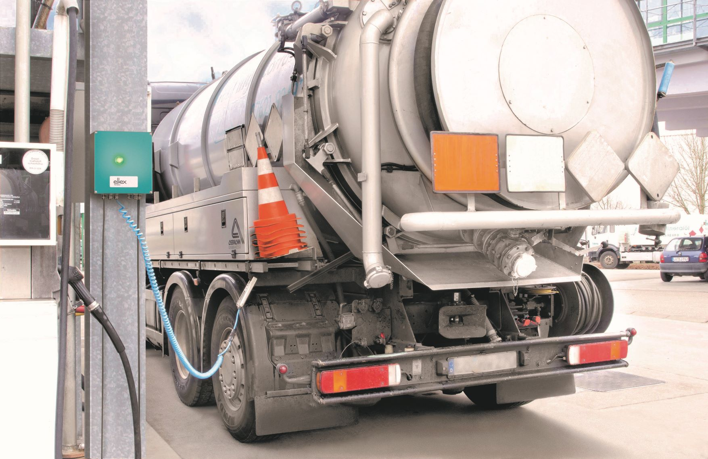
Photo:
Truck grounding with TERRABOX

Paint tank storage
As a rule, the truck delivers mobile paint tanks in the volume of about 600l. The paint tanks are brought to the company's tank room, where they are pumped into the individual storage tanks. As a rule, up to 40 stationary storage tanks are available, with a volume of up to 2000L.

Ground monitoring when pumping the paint tanks into each individual storage tank is a predestined application for mobile ground monitoring with the battery-operated TERRALIGHT. The mobile TERRALIGHT is connected via 2 clamps to the paint tank to be emptied and potential equalization and signals the safe ground connection via the flashing LEDs in the TERRALIGHT and the ground clamp.

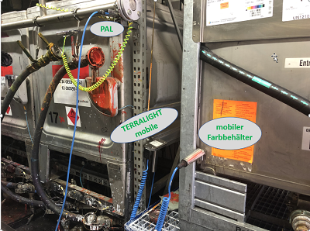
Photo:
TERRALIGHT mobile in paint tank storage

Supply room
The solvent-based ink for the print jobs is filled or pumped in the supply room. Ink tanks with a volume of 25L up to 2000L can be located in this room. When using very large and small tanks, active ground monitoring with the battery-operated TERRALIGHT is ideal and can be installed without great effort.

Gravure printing press
On the gravure printing press, there is an ink container on each printing unit, into which smaller quantities of ink are filled manually, usually with up to 25l buckets. Each printing unit is equipped with a number of passive grounding contactors. Depending on the print job, however, larger ink containers of up to 2000l are also driven directly to the printing unit. The ink is then pumped directly into the ink fountain of the printing unit via a pump. Due to the large amount of solvent-based ink that is pumped directly at the printing press, grounding should be controlled to significantly increase safety in this area.

The battery-powered TERRALIGHT is the first choice because of its very easy installation. Usually 2 TERRALIGHT are installed on a 10 color press to bridge the distance of the ground monitoring system to the large ink tanks.

But even the smaller containers that are manually poured from a bucket into the paint tray can be controllably grounded with the TERRALIGHT.

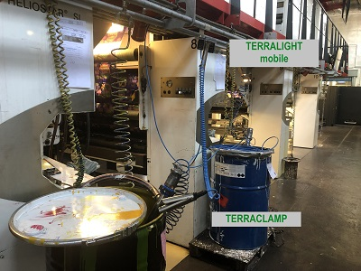
Photo:
TERRALIGHT mobile gravure printing press

Part 3: Eltex products

Controlled grounding process
With TERRACONTROL TUE30 active ground monitoring systems, the grounding of the object is continuously monitored from the ground contactor to the equipotential bonding via an intrinsically safe circuit. When integrated into the process control system, the system offers a decisive plus in safety.

Insufficient grounding due to painted barrels, cable breaks, a defective equipotential bonding connection or the simple forgetting of the personnel to connect the clamp is detected by the active system and the process is not released if the appropriate wiring is used. The use of the Eltex ground monitoring systems guarantees hazard-free grounding. Together with the Eltex grounding clamps and cable rewinders, optimum handling is achieved and safety is decisively increased!

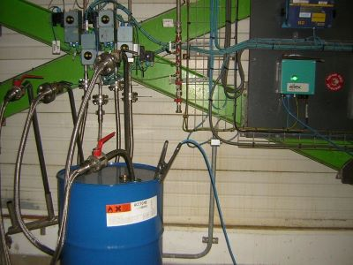
Photo:
Barrel grounding with TERRABOX

TERRALIGHT:
Battery-operated controlled grounding, fixed or mobile
The newly developed TERRALIGHT active ground monitoring system is a battery-operated and completely mains-independent system that monitors whether the object to be grounded is conductively connected to the equipotential bonding system.

TERRALIGHT indicates the correct ground connection by a green LED flashing light, and when used in combination with TERRACLAMP, this light is also displayed on the clamp.

The mains-independent supply offers decisive advantages in terms of minimal installation effort. There is no need to lay any supply cables. An integrated wall bracket enables simple and quick installation.

If the TERRALIGHT is operated with two ground clamps, it can even be used as a mobile unit, which opens up many other possible applications.

Photo Eltex:
TERRALIGHT product picture
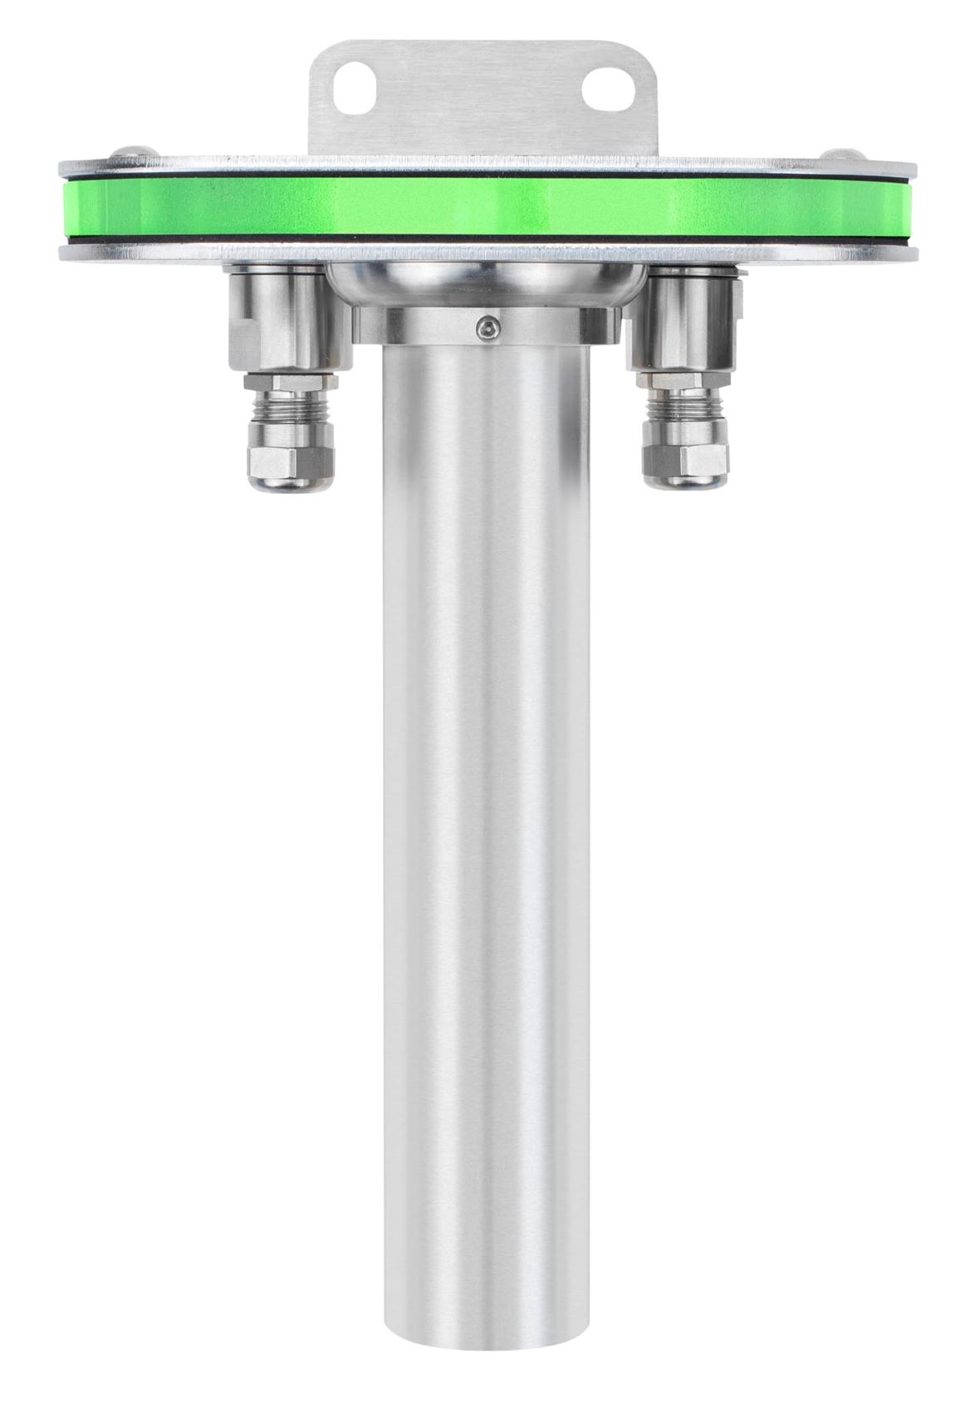

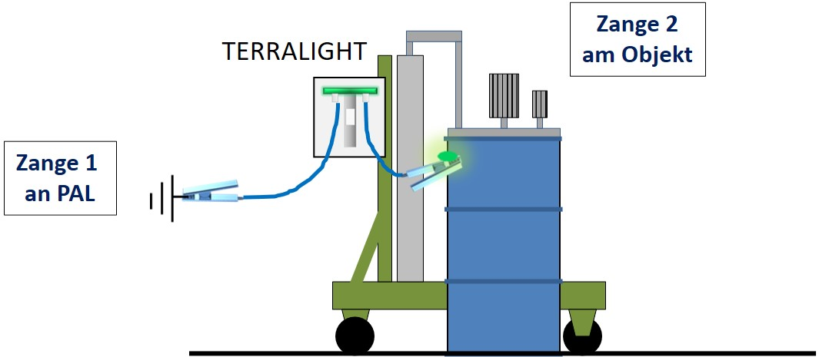

Illustration Eltex:
TERRALIGHT and TERRACLAMP (LED) on mobile stirrer

More about electrostatic grounding:
www.eltex-grounding.de


Author:
Kai Werner
Eltex-Elektrostatik-GmbH
Dipl.-Wirtsch.-Ing. (FH)
Technical consultant
kai.werner@eltex.de

Eltex-Elektrostatik-GmbH, 20. July 2021

